HSA Central- Online Account Opening
Employer Name: JACKSON COUNTY, IL
HSA Central Employer Online Account Opening URL:
https://centralparticipant.HSACentral.net/Login.aspx?sec=ASF-CB1092

- Provide your Personal Information and create your username and password to open your Health Savings Account (HSA). Your username and password will be used when logging into your HSA at HSACentral.net
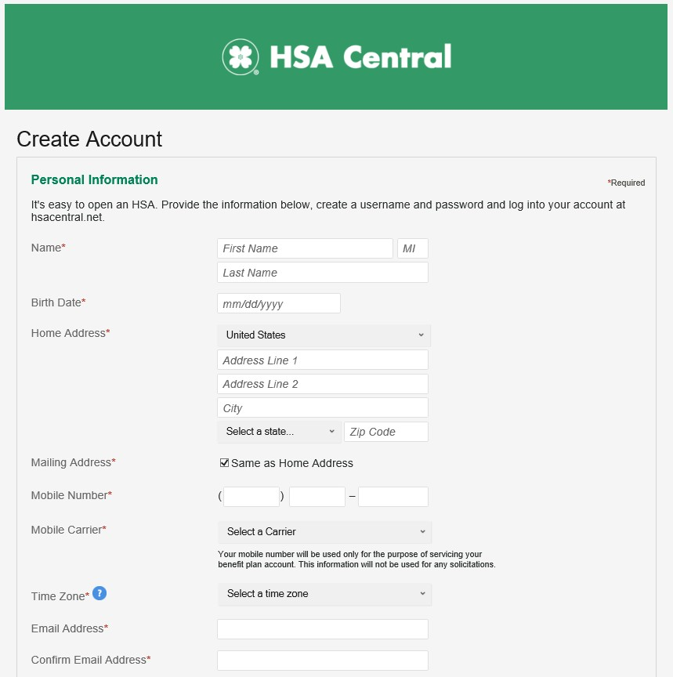

- Establish Security questions for your HSA.
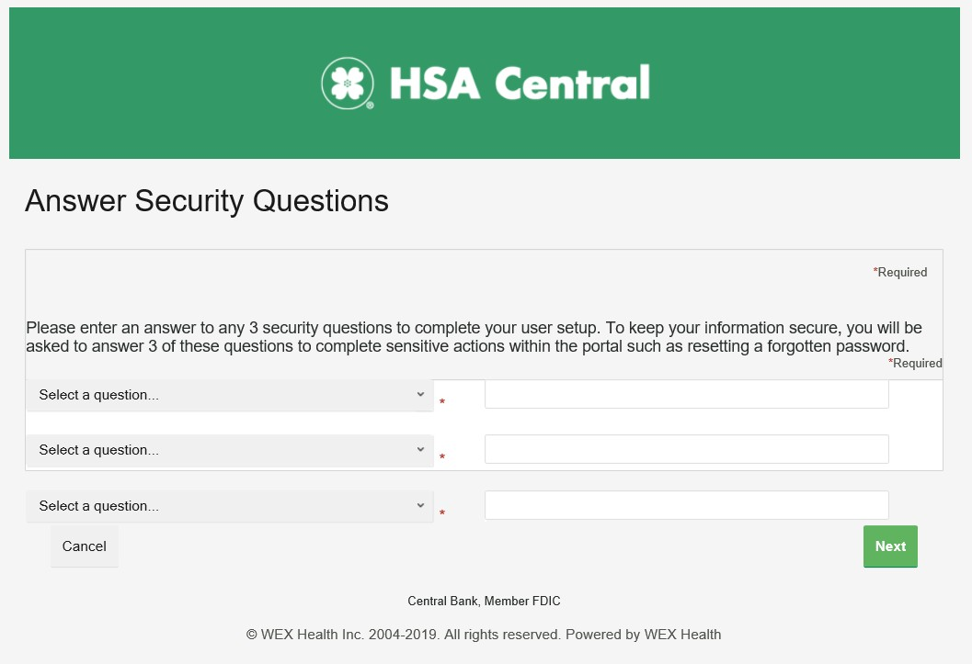

- Review the information.
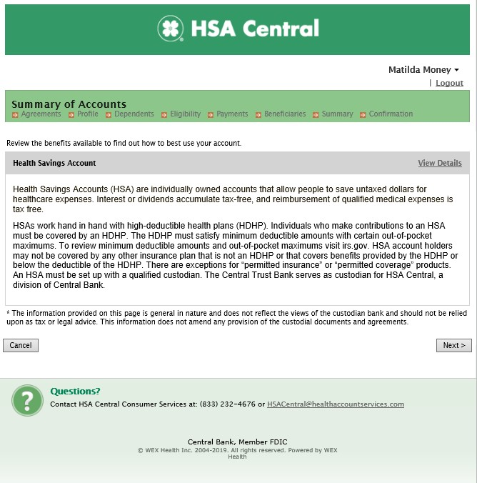

- Click the Read and agree link to accept the Agreements and Disclosures for your HSA.
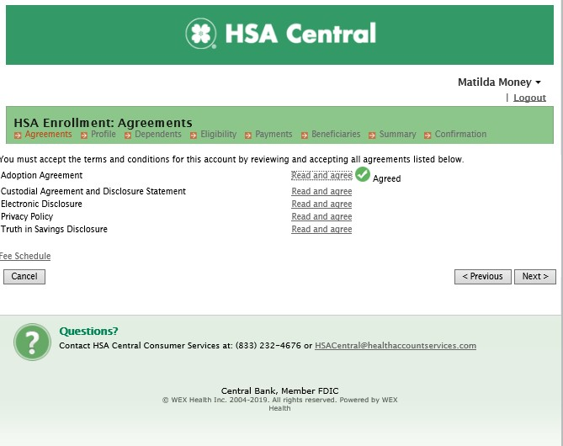

- Complete your Demographic information including SSN and phone number.

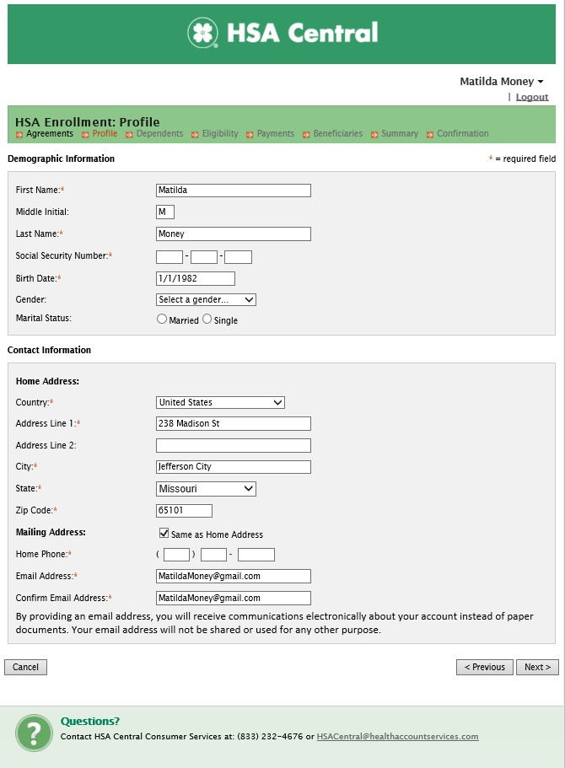

- Add any dependents or a spouse to your HSA profile. This makes it easy to associate healthcare expenses with specific individuals within your household, assign them as beneficiaries later, or issue them an HSA Central Debit Mastercard used for eligible healthcare expenses related to your HSA.
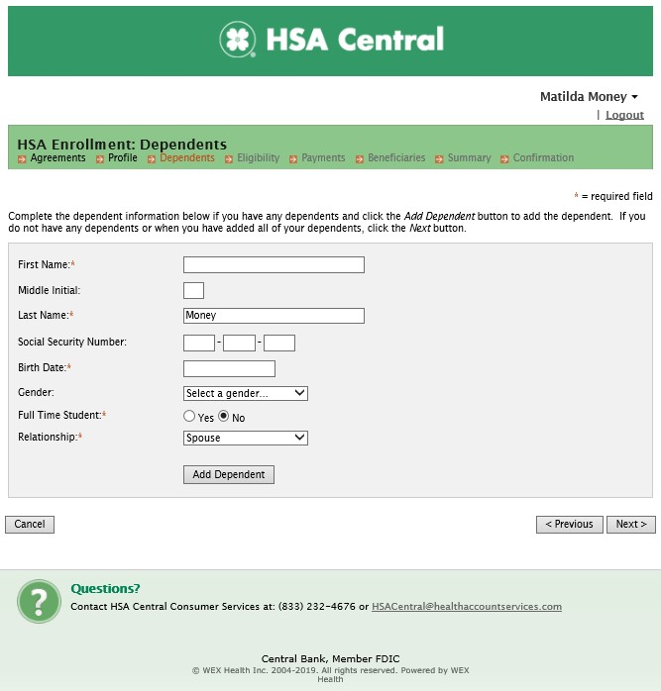

- Ensure you meet the eligibility requirements and have a high-deductible health plan to open the HSA. Check the box to certify you’re eligible. Select your health plan’s level of coverage from the drop down.
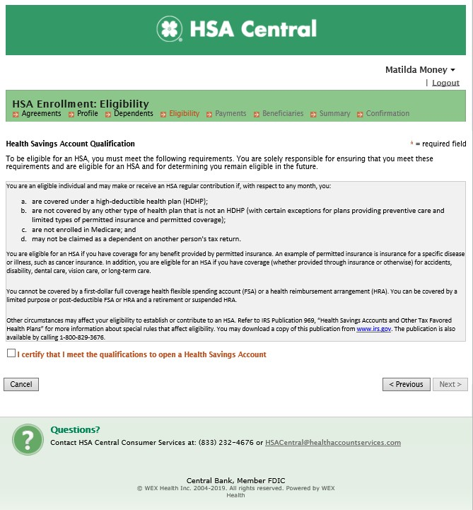

- Select the Issue Card box to have your HSA Central Debit Mastercard mailed to you. You can also add a bank account that will make it easier later to reimburse yourself for eligible medical expenses where you might not have used your HSA Central debit card or to add additional contributions to your HSA.
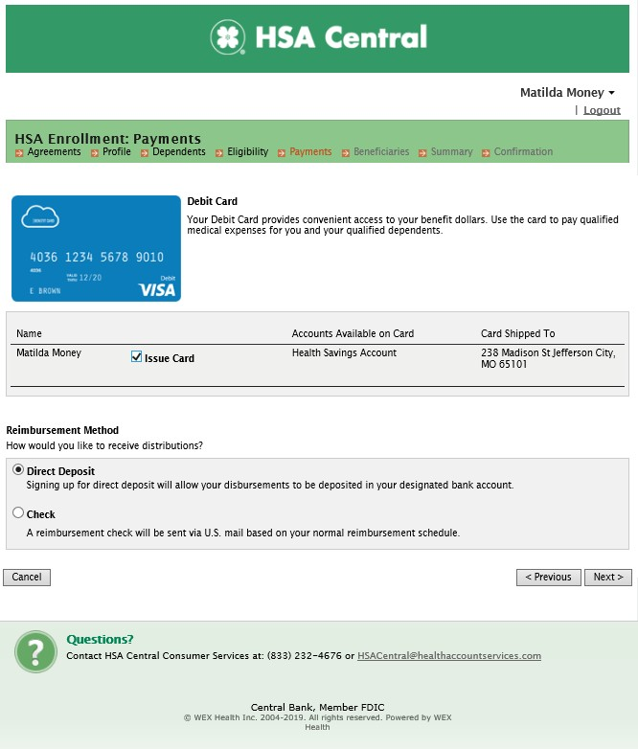

- Add your Beneficiaries by completing the fields, or you can select dependents you previously added.
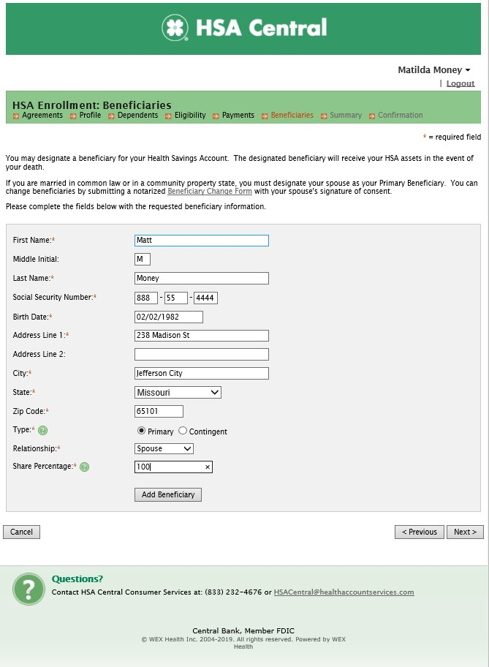

- Verify the information you entered is correct.
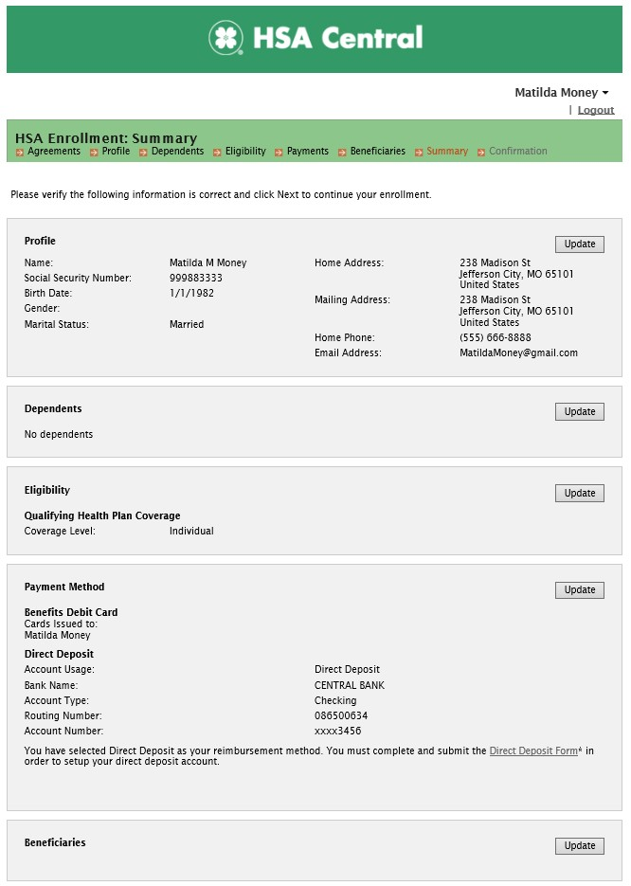

- Check the boxes for final authorization and Submit.
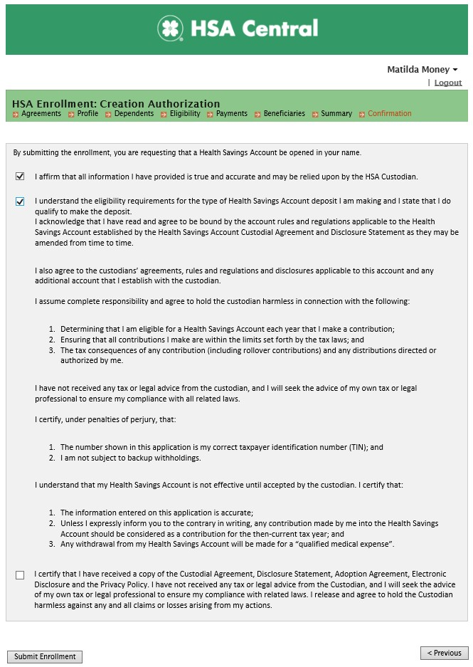

- Your HSA enrollment is complete.
