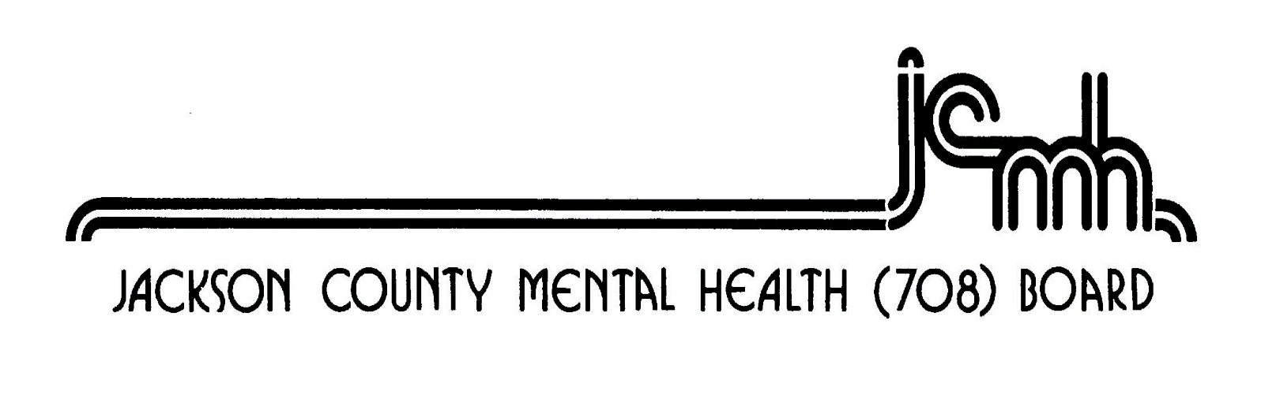

1001 Walnut Street Murphysboro, Illinois 62966 618-687-7240

2024 Meeting Schedule

Day/Date Meeting Time Host Agency Street Address

Monday Sheriff’s 1001 Mulberry Street
February 26th Sheriff’s Office 5:30p.m. Office Murphysboro, IL 62966

Monday Sheriff’s 1001 Mulberry Street
April 15th Sheriff’s Office 5:30p.m. Office Murphysboro, IL 62966

Monday County 1001 Walnut Street
June17th Courthouse 6:00p.m. Courthouse Murphysboro, IL 62966
Public Hearing (prior to meeting) 5:30p.m.

Monday Sheriff’s 1001 Mulberry Street
August 19th Sheriff’s Office 5:30p.m. Office Murphysboro, IL 62966

Monday Sheriff’s 1001 Mulberry Street
October 21st Sheriff’s Office 5:30p.m. Office Murphysboro, IL 62966

Monday Sheriff’s 1001 Mulberry Street
December 16th Sheriff’s Office 5:30p.m. Office Murphysboro, IL 62966

(Please check the County Website for the most up-to-date information Jackson County, IL | Home (jacksoncounty-il.gov) )

