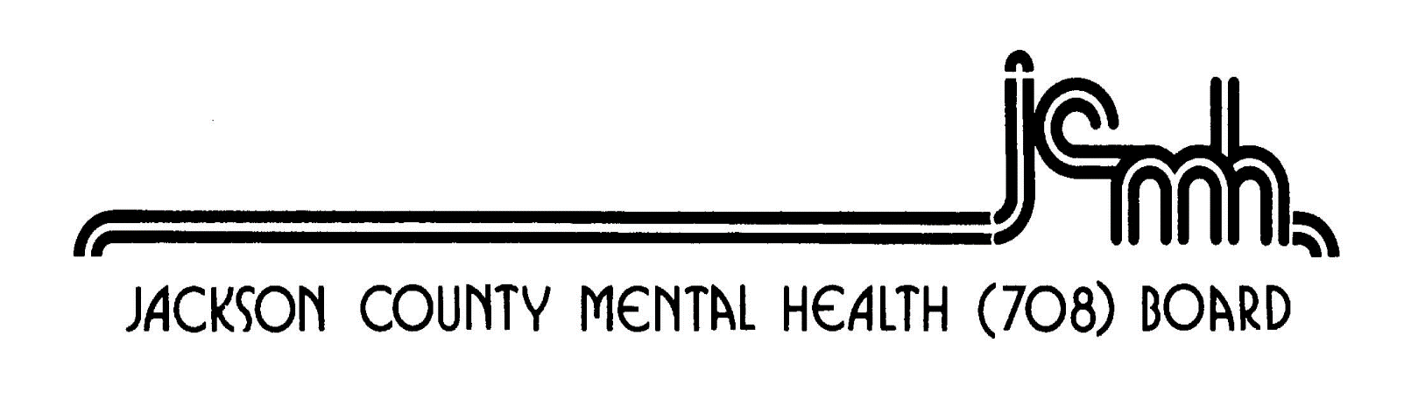
1001 Walnut Street Murphysboro, Illinois 62966 618-687-7240

2026 Funding Application
Timeline Dates

Monday, April 21, 2025 708 Approves 2026 Funding Application

Friday, April 25, 2025 Funding Application available on 708 Website
Funding Applications emailed to current agencies
Funding Application published in the local papers

Friday, May 23, 2025 Funding Applications due to County Board Office 2pm

Friday, May 30, 2025 708 Board emailed applications for review and scoring

Friday, June 06, 2025 708 Board reviews/scoring due to County Board Office 2pm

Monday, June 16, 2025 5:30pm 708 Public Hearing at the Jackson County Courthouse

Monday, June 16, 2025 6:00pm 708 Board Meeting at the Jackson County Courthouse

